Calendar Of Events  Sonora TANF Modesto TANF  14520 Mono Way Suite 200 2005 Evergreen Ave Suite 800  Sonora, CA 95370 Modesto CA 95350 | September 2021
WORKSHOPS ARE OFFERED TO ALL NATIVE AMERICAN FAMILIES RESIDING IN TUOLUMNE, CALAVERAS, AND STANISLAUS COUNTIES. WORKSHOPS ARE PRESENTED IN PERSON AND ON ZOOM. ALL MATERIALS ARE PROVIDED AT NO COST TO REGISTRANTS.
Sunday | Monday | Tuesday | Wednesday | Thursday | Friday | Saturday
 | 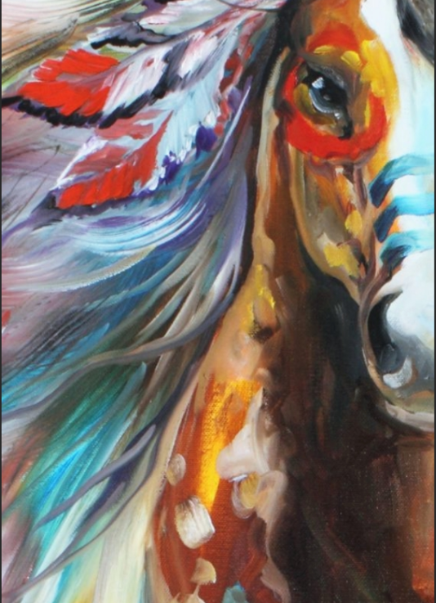 | 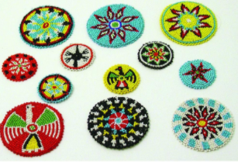 | 1  Beaded Rosettes (Stanislaus)  In Person 5pm-7:30pm | 2 | 3 | 4
5 | 6  Office Closed | 7 Beaded Rosettes  (Tuolumne)  In Person 5pm-7:30pm  Virtual Youth Talking Circle 12-17 5pm-7pm | 8  Beaded Rosettes (Stanislaus)  In Person 5pm-7:30pm | 9 | 10  MERs Due | 11  Acorn Festival @ Tuolumne Rancheria
12  Acorn Festival @ Tuolumne Rancheria | 13  Beaded Rosettes (Calaveras)  In Person 5pm-7:30pm | 14Beaded Rosettes  (Tuolumne)  In Person 5pm-7:30pm  Virtual Youth Talking Circle 12-17 5pm-7pm | 15  Beaded Rosettes (Stanislaus)  In Person 5pm-7:30pm | 16 | 17 | 18
19 | 20  Beaded Rosettes (Calaveras)  In Person 5pm-7:30pm | 21 Beaded Rosettes  (Tuolumne)  In Person 5pm-7:30pm  Virtual Youth Talking Circle 12-17 5pm-7pm | 22  Beaded Rosettes (Stanislaus)  In Person 5pm-7:30pm | 23 | 24  California Indian Day  Office Closed | 25
26 | 27  Beaded Rosettes (Calaveras)  In Person 5pm-7:30pm | 28 Beaded Rosettes  (Tuolumne)  In Person 5pm-7:30pm  Virtual Youth Talking Circle 12-17 5pm-7pm | 29  Beaded Rosettes (Stanislaus)  In Person 5pm-7:30pm | 30 | Coming Up In October  - In Person Moccasin Making class | 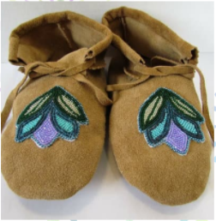
TRIBAL TANF PHONE # 1-844-303-8263
*Cash Aid Clients Are Priority - Then All Other Eligible Families *All Events Are Drug and Alcohol Free

*All Events Are Drug and Alcohol Free

