Calendar Of Events  Sonora TANF Modesto TANF  14520 Mono Way, Suite 200 2005 Evergreen Ave, Suite 800  Sonora, CA 95370 Modesto, CA 95350 |   August 2021
WORKSHOPS ARE OFFERED TO ALL NATIVE AMERICAN FAMILIES RESIDING IN TUOLUMNE, CALAVERAS, AND STANISLAUS COUNTIES. WORKSHOPS ARE PRESENTED IN PERSON AND ON ZOOM. ALL MATERIALS ARE PROVIDED AT NO COST TO REGISTRANTS.
Sunday | Monday | Tuesday | Wednesday | Thursday | Friday | Saturday
1  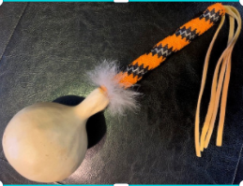 | 2 Beaded Gourd Rattle (Calaveras)  In Person 5pm-7:30pm | 3 Beaded Gourd Rattle (Tuolumne)  In Person 5pm-7:30pm  Virtual Youth Talking Circle 4-12 3:30pm-4:30pm / 12-17 5pm-7pm | 4 | 5  Beaded Gourd Rattle (Stanislaus)  In Person 5pm-7:30pm | 6 | 7  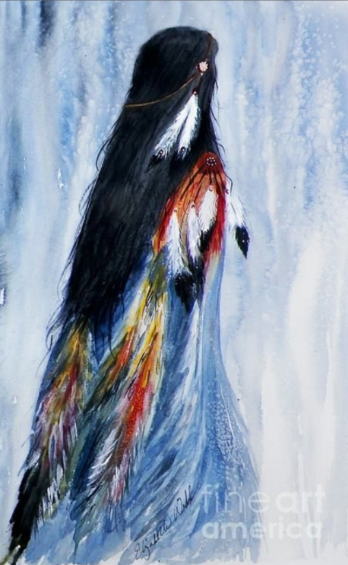
8  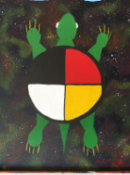 | 9 Beaded Gourd Rattle & Backpack Event  In Person (Calaveras)  5pm-7:30pm | 10 Beaded Gourd Rattle & Backpack Event  In Person (Tuolumne) 5pm-7:30pm  Virtual Youth Talking Circle 4-12 3:30pm-4:30pm / 12-17 5pm-7pm  (Zoom)  Mers Due | 11 | 12  Beaded Gourd Rattle & Backpack Event  In Person (Stanislaus)  5pm-7:30pm | 13 | 14  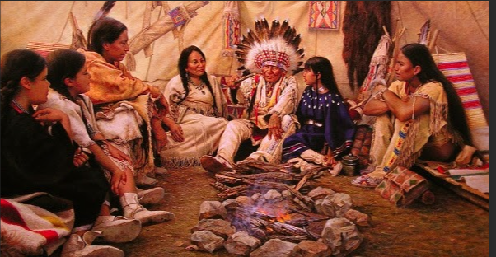
15 | 16 Beaded Gourd Rattle (Calaveras)  In Person 5pm-7:30pm | 17 Beaded Gourd Rattle (Tuolumne)  In Person 5pm-7:30pm  Virtual Youth Talking Circle 4-12 3:30pm-4:30pm / 12-17 5pm-7pm | 18 | 19  Beaded Gourd Rattle (Stanislaus)  In Person 5pm-7:30pm | 20 | 21  
22  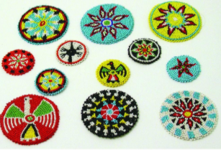 | 23 Beaded Rosettes (Calaveras)  In Person 5pm-7:30pm | 24 Beaded Rosettes (Tuolumne)  In Person 5pm-7:30pm  Virtual Youth Talking Circle 4-12 3:30pm-4:30pm / 12-17 5pm-7pm | 25  Beaded Rosettes(Stanislaus)  In Person 5pm-7:30pm | 26 | 27 | 28
29 | 30 Beaded Rosettes (Calaveras)  In Person 5pm-7:30pm | 31 Beaded Rosettes (Tuolumne)  In Person 5pm-7:30pm  Virtual Youth Talking Circle 4-12 3:30pm-4:30pm / 12-17 5pm-7pm |  | Coming Up In September:  - Beaded Rosettes Continues
TRIBAL TANF PHONE # 1-844-303-2863
NOTES: _____________________________________________________________________________________________________________________________________________________
____________________________________________________________________________________________________________________________________________________________

