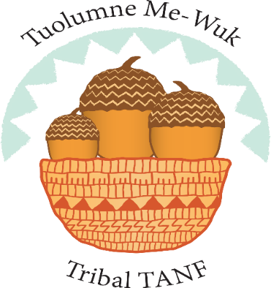 | Calendar of Events  June 2021
1-844-303-8263 | Workshops are offered to all Native American Families residing in Tuolumne, Calaveras, and Stanislaus counties. Workshops are presented on ZOOM. All materials are provided at no cost to registrants.

Sunday | Monday | Tuesday | Wednesday | Thursday | Friday | Saturday
 |  |  |  | 1 | 2 | 3
 |  | 1 Virtual Talking Circle  4-12 years  3:30pm-4:30pm  12-17years  5pm-7pm | 2  Sand Art  Workshop  5pm-6:30pm | 3 | 4 | 5
6 | 7 Sand Art  Workshop  5pm-6:30pm  Family Night Gathering 5-7:30pm | 8 Virtual Talking Circle  4-12 years  3:30pm-4:30pm  12-17years  5pm-7pm | 9  Sand Art  Workshop  5pm-6:30pm | 10  MERS Due | 11 | 12  Black Oak Indigenous Market from 10am-4pm
13 | 14 Sand Art  Workshop  5pm-6:30pm  Family Night Gathering 5-7:30pm | 15 Virtual Talking Circle  4-12 years  3:30pm-4:30pm  12-17years  5pm-7pm | 16  Sand Art  Workshop  5pm-6:30pm | 17 | 18  Registration  Deadline for  Medallion Making Workshop | 19
20 | 21 Sand Art  Workshop  5pm-6:30pm  Family Night Gathering 5-7:30pm | 22 Virtual Talking Circle  4-12 years  3:30pm-4:30pm  12-17years  5pm-7pm | 23  Sand Art  Workshop  5pm-6:30pm | 24 | 25 | 26
27 | 28 Sand Art  Workshop  5pm-6:30pm  Family Night Gathering 5-7:30pm | 29 Virtual Talking Circle  4-12 years  3:30pm-4:30pm  12-17years  5pm-7pm | 30  Medallion Making Workshop  5pm-6:30pm |  | Coming in July Beaded Gourd Rattle  &  The opening of Live in person Classes | 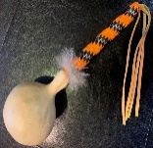
Sonora TANF Modesto TANF NOTES: __________________________________________
14520 Mono Way 2005 Evergreen Ave _________________________________________________
Suite 200 Suite 800 _________________________________________________
Sonora, CA 95370 Modesto, CA 95350 _________________________________________________
_________________________________________________
_________________________________________________

