Calendar of Events
July 2021
1-844-303-8263 | Workshops are offered to all Native American Families residing in Tuolumne, Calaveras, and Stanislaus counties. Workshops are presented on ZOOM. All materials are provided at no cost to registrants.
Sunday | Monday | Tuesday | Wednesday | Thursday | Friday | Saturday
 |  |  |  | 1 | 2 | 3
 |  |  |  |  | Beaded Gourd Rattle Registration Deadline
4  Independence  Day! | 5  Office Will Be  Closed! | 6 Virtual Talking Circle  4-12 years  3:30pm-4:30pm  12-17years  5pm-7pm | 7 Beaded Medallion Making  Workshop  5pm-6:30pm (Zoom) | 8 | 9  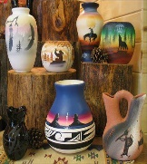 | 10 MERS Due  Indigenous Market  At Chicken Ranch
11  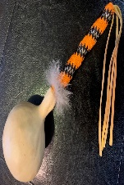 | 12  Beaded Medallion Making  Workshop  5pm-6:30pm  (Zoom)  Beaded Gourd Rattle Workshop(Calaveras)  5pm-7:30pm | 13 Virtual Talking Circle  4-12 years  3:30pm-4:30pm  12-17years  5pm-7pm  Beaded Gourd Rattle Workshop(Tuolumne)  5pm-7:30pm | 14  Beaded Medallion Making  Workshop  5pm-6:30pm  (Zoom) | 15  Beaded Gourd  Rattle Workshop  (Stanislaus)  5pm-7:30pm | 16 | 17
18 | 19  Beaded Medallion Making  Workshop  5pm-6:30pm (Zoom)  Beaded Gourd Rattle Workshop(Calaveras)  5pm-7:30pm | 20 Virtual Talking Circle  4-12 years  3:30pm-4:30pm  12-17years  5pm-7pm  Beaded Gourd Rattle Workshop(Tuolumne)  5pm-7:30pm | 21  Beaded Medallion Making  Workshop  5pm-6:30pm  (Zoom) | 22  Beaded Gourd  Rattle Workshop  (Stanislaus)  5pm-7:30pm | 23 | 24
25 | 26  Beaded Gourd Rattle Workshop(Calaveras)  5pm-7:30pm | 27 Virtual Talking Circle  4-12 years  3:30pm-4:30pm  12-17years  5pm-7pm  Beaded Gourd Rattle Workshop(Tuolumne)  5pm-7:30pm | 28 | 29  Beaded Gourd  Rattle Workshop  (Stanislaus)  5pm-7:30pm | 30  Coming Up In August:  -Continuation Of Beaded Gourd Rattle  - Starting Beaded Rosettes | 31  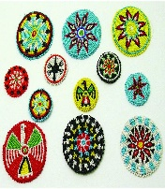
Sonora TANF Modesto TANF NOTES: __________________________________________
14520 Mono Way 2005 Evergreen Ave _________________________________________________
Suite 200 Suite 800 _________________________________________________
Sonora, CA 95370 Modesto, CA 95350 _________________________________________________
_________________________________________________
_________________________________________________

